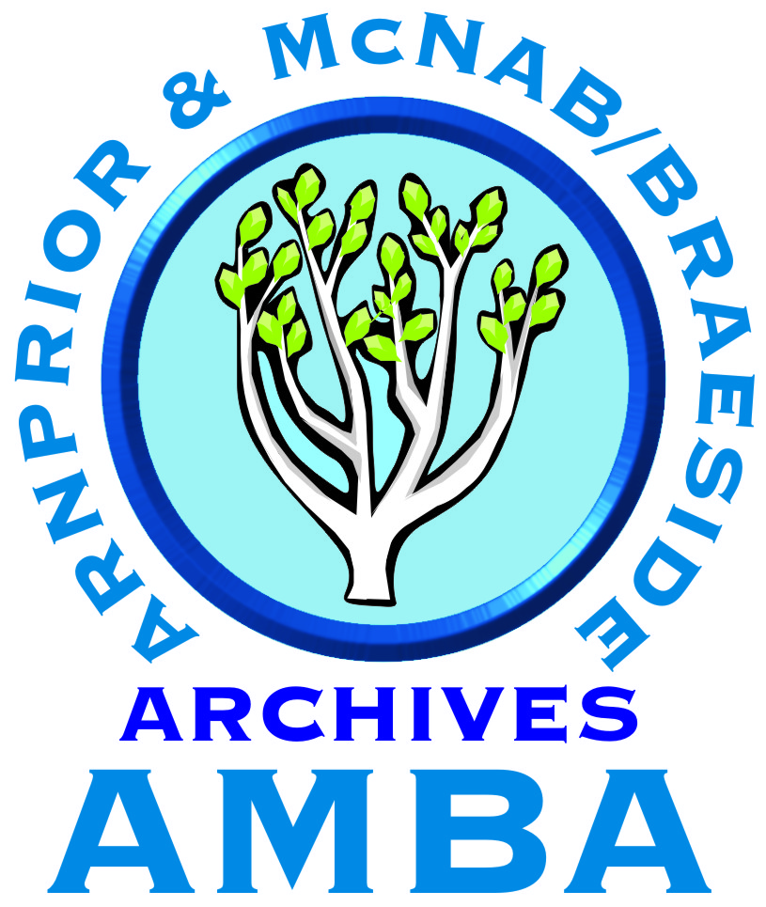 ARNPRIOR & MCNAB/BRAESIDE ARCHIVES
www.ADArchives.org

AMBA is a non-profit, charitable organization which acquires, preserves and makes available important historical documents pertaining to the town of Arnprior and the Township of McNab/Braeside, serving local and world-wide clients with the support of a dedicated volunteer base.

CONSULTING ARCHIVIST
Seeking a knowledgeable individual to provide leadership in all archives services, with proven capabilities in customer service, communication, self-management and volunteer supervision.

Contract; 32 hr./wk. flexible; Hourly rate $25-$30/hr with no benefits

Please send your application, including a detailed resumé and cover letter (MS Word or pdf format), stating
Contract: Consulting Archivist by June 4, 2023 to:

Email: arnpriorarchives@gmail.com
Arnprior & McNab/Braeside Archives
21B Madawaska Street Arnprior, Ontario K7S 1R6
ATTN: Irene Robillard

We thank all applicants for their interest. Only those considered for an interview will be contacted.

For a full Job Posting, including Qualifications, please visit www.ADArchives.org

